Emma De Bernard Treviso, 22nd March 2020

ST. PATRICK’S DAY

1. What did you understand about the life of St. Patrick ?

St. Patrick was born in Britain in 387 and his name was Padràig. He came from a family of priests.

1. Which century did he live in?

He lived between the fourth and fifth century after Christ.

1. When was he made slave by the Irish pirates and what did he do after that?

When he was 16 he was made slave by the Irish pirates and he was forced to tend sheep in Ireland.

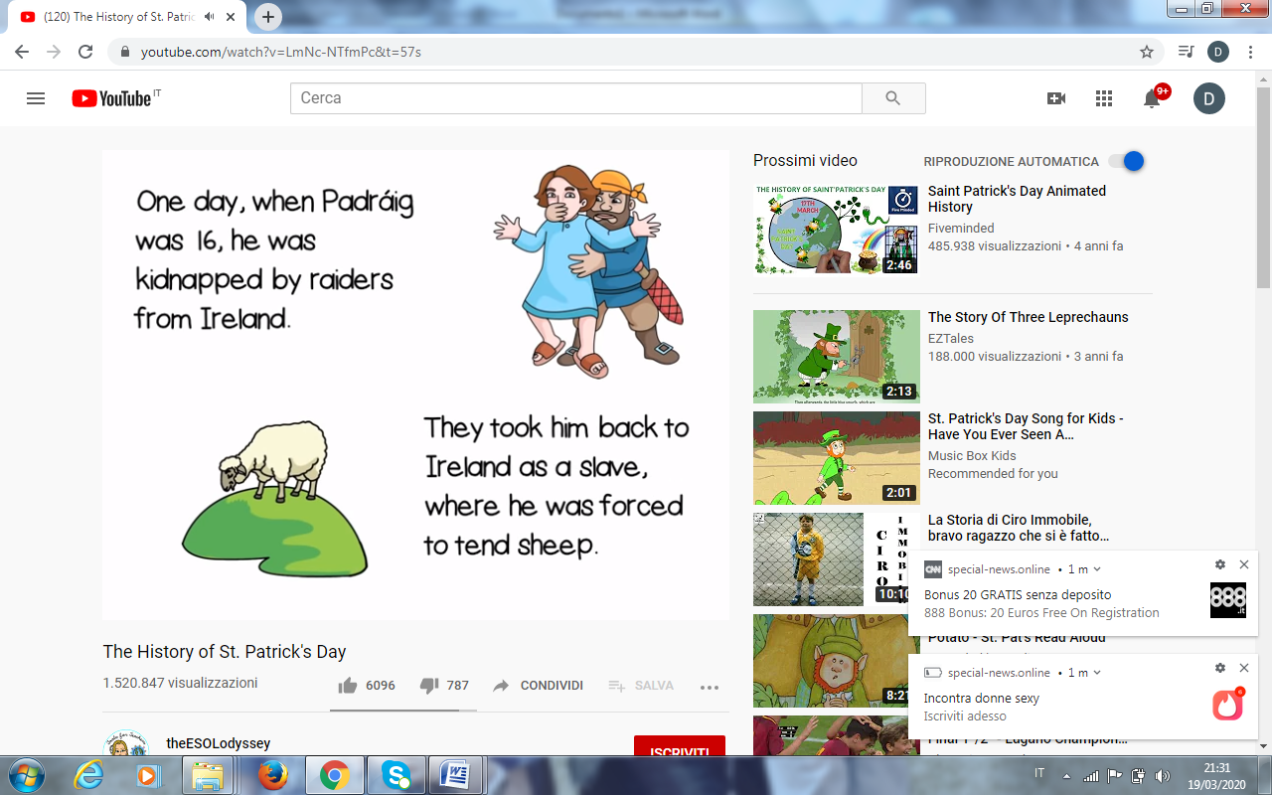 

When he was 20 he had a dream that, he believed, came from God.

Then based on his dream he escaped from his captors and he came back to Britain to his family. 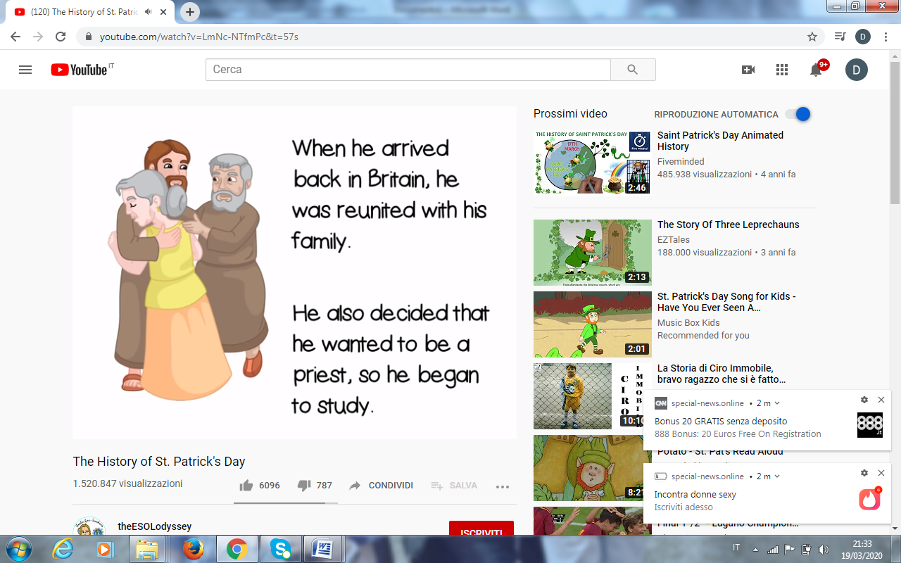

He decided that he wanted to be a priest, he studied for many years and he was made a bishop.

He returned to Ireland and he converted all Ireland to Christianity.

1. Why do many American citizens celebrate St. Patrick’ s day today?

Because they are people with Irish heritage. Their ancestors moved to the US during the Irish potato famine in 1840.

1. What are the symbols of Ireland?

The symbols of Ireland are the shamrock and the leprechaun with a pot of gold.

